Kira Burt, Devika Gates, Ashlee McQueen

Tournament Directors

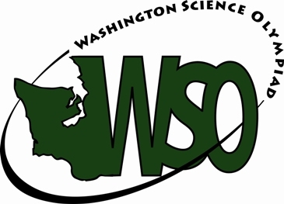

March 9, 2024

**WASHINGTON SCIENCE OLYMPIAD**

*PRESENTS THIS*

CERTIFICATE OF PARTICIPATION

*TO*

*FOR PARTICIPATING IN THE*

2024 EASTERN WASHINGTON

REGIONAL SCIENCE OLYMPIAD TOURNAMENT

*AT SPOKANE FALLS COMMUNITY COLLEGE*

